Use-Case Realization Report (Analysis)
Manage Error

Issue 1.0
Revision History
Date | Issue | Description | Author
15/May/2011 | 1.0 | Initial Document | Koh Ming Jin

Table of Contents
1. Brief Description 4
2. Flow of Events 4
2.1 Standard Flow 4
2.1.1 Creation of error codes 4
2.1.2 Update / deletion of error codes 4
2.2 Exception 4
3. Interaction Diagrams 4
3.1 Collaboration Diagram for Manage Error 4
4. Participating Objects 5
4.1 Manage Error Page 5
4.2 Error Controller 5
4.3 Error 5
5. Class Diagrams 5
5.1 Domain Class Diagram: Manage Error 5
6. Derived Requirements 6

Use-Case Realization Report
Manage Error

Brief Description
This use case enables an operation manager to manage error records. Managing error records includes creating, updating and deleting of error records. The required information includes the error ID, error name and error explanation.

Flow of Events
The standard flow of events for this use case and any exceptions are described in the following subsections. See section 3.1 for an overview of the participating Actors and Domain Objects.

Standard Flow
The flow of events is described as follows:

- The use case starts when Operation Manager selects the Manage Error option of the system.
- The Manage Error Page is displayed.

Creation of error codes
- The Operation Manager provides all the required details concerning a new error code into the Manage Error Page.
- The existence of the new error in the system is checked against the error information held by the database.
- If the new error is not existent, the error record is created with the supplied details.
- The use case terminates.

Update / deletion of error codes
- The Operation Manager provides all the required details concerning an existing error into the Manage Error Page or selects the records which he/she wants to view from the Manage Error Page.
- The existence of the error in the system is checked against the error information held by the database.
- If the error is in the current database and the selected option is to either delete or update,
  - The selected error record will be updated with the supplied details.
  - The selected error record will be deleted.
- The use case terminates.

Exception
- The error ID does not exist for update or delete option. If the input error ID is not found to be an existing one, the error modification or deletion will fail. An error message is displayed, and the Manage Error Page is displayed again.
- The new error code to be created already exists in the current system. An error message is displayed, and the Manage Error Page is displayed again.

Interaction Diagrams

Collaboration Diagram for Manage Error
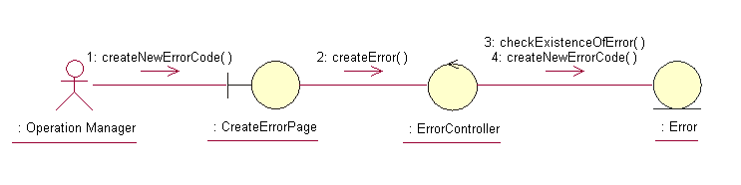
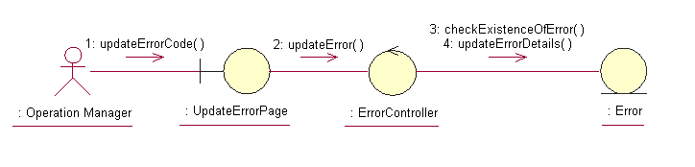

Participating Objects

Manage Error Page
This object renders the contents to allow authorized actors to perform the manage error requests. The Director, Department Manager and Operation Manager actors use this object.

Error Controller
This object acts as the middleman between Manage Error Page and the Error object. It will translate interactions with the view into actions to be performed by the Error object.

Error
This object stores the details concerning the error of the COMS.

Class Diagrams

Domain Class Diagram: Manage Error
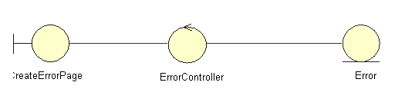
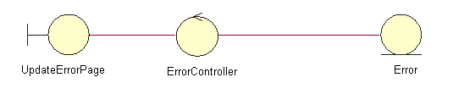

Derived Requirements
The Operation Manager PC keyboard and mouse will be used to enter error details (if any) and view all the system responses.

